Use Cases

Data needed for Use case 3 (encourage firms to go paperless)
Amount of paper used – cost of paper.
Amount of paper wasted – from misprints.
Number of printers in workplace
Energy of printers
Number of times printers are used.
Necessity of printing -> could batch print if more efficient than have printer off/hibernating the rest of the time.
Identify where the most amount of paper is used in the building.

Data needed for Use case 5
Need location, elevation, height of building and size of land -> use map to find out whether solar panels / wind turbines would work better/effectively for location.
Need if there are any already installed renewable energy sources.
Cost of each renewable energy source and how much power it would be able to produce.
Size that the new source would take up and if there is space for it on the company land without interfering with the looks/functionality of the building/land.
Likelihood of being able to run 100% off renewable energy.
Building and out of building energy consumption?
Output some possible simple things that could be done to reduce unnecessary energy usage (lights)
Use current prices for electricity (needed data) to calculate the estimated price difference.
Find a solution ideally with lower costs more renewables used and reliable energy.

Includes regional as well : Digest of UK Energy Statistics (DUKES): renewable sources of energy - GOV.UK (www.gov.uk)
Independent of the Government:
Low carbon and renewable energy economy estimates - Office for National Statistics (ons.gov.uk)
Energy network indicators | Ofgem
Whole world but has totals Data (irena.org)
More general information on renewables
Renewable Energy - Our World in Data
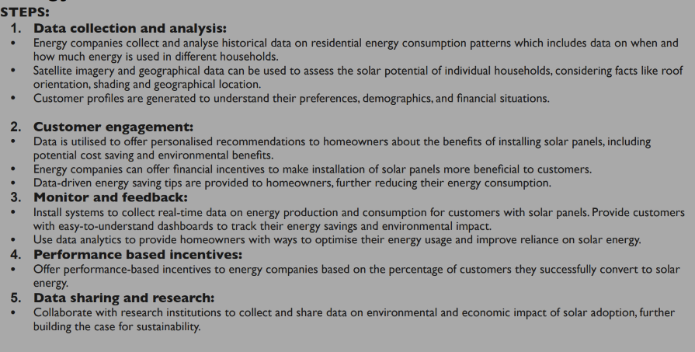

Possible Data that could be used and how it would be used
subnational_electricity_consumption_statistics_2005-2021.xlsx (live.com)
Shows electricity consumption in different years in different local authority between domestic and non-domestic users
From this we would be able to gather whether it would be possible to run their houses of 100% solar energy. It might also influence the recommendation on any battery storage for the solar panels for night / non sunny days.
subnational_electricity_consumption_distribution_2021.xlsx (live.com)
Distribution of the electricity to give a vague spread to give the likelihood that the houses selected will use the amount assumed and possibly use it to assume a worst case for amount of electricity consumed or for days where the most energy is used in the household.
Solar_Costs_2022-23.xlsx (live.com)
The costs and number of solar panels put up each year. Can pair with the amount of electricity it will produce and cost difference to find the amount of money saved. Also has a possibility that houses in the area can have solar panels and data from them could be found out and used in aid of getting the correct solar panel to be cost effective for the customer and save them the most without having to spend unnecessarily.

Renewable power generation costs in 2021 (irena.org)
Publication that gives some good details about all renewable sources and reasons for their price changes due to material prices and supply chain struggles. Comes with a data sheet with more data however this covers the world so some figures are irrelevant to us if we were to use it purely for the UK.

Cost of Solar Panels in the UK | 2023 prices updated (fmb.org.uk)
Solar panel cost calculator
ET_7.3_OCT_23.xlsx (live.com)
Shows daylight hours for different parts of the country which could impact how much a solar panel can produce in one day.
Weather_OCT_23.ods (live.com)
Includes rainfall which could affect the amount of sun that each area could get reducing the effectiveness of the solar panels.

Facts found
Levelized cost of electricity by solar panels has been declining yearly by 13%
The cost in Europe declined by 91% between 2010 and 2021
The World has 1 TW solar capacity
In the UK there is 15GW of capacity – around 1 GW of this was in the last year
Domestic solar panels almost doubled in 2022
Around 1.3 million homes of 29 million have solar panels
Just over 1000 solar farms

The operation and maintenance costs of utility-scale solar PV plants have declined in the last decade, driven by module efficiency improvements, which have reduced the surface area required for every MW of capacity.
Solar resource maps and GIS data for 200+ countries | Solargis
For data on the sunlight as seen in pictures below
Amount of Bright Sunshine During 2020, per UK Region
Solar Panel Statistics 2023: Everything You Need To Know (theecoexperts.co.uk)

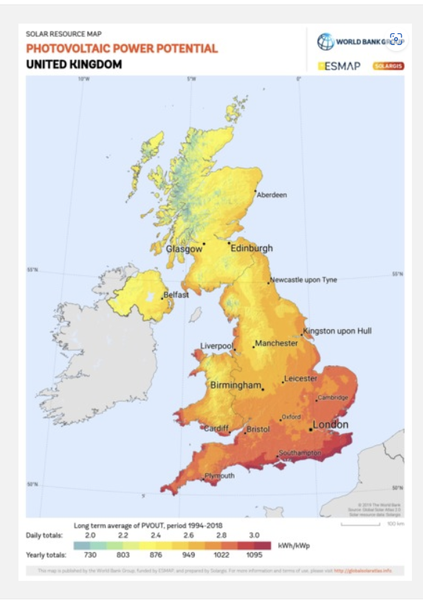

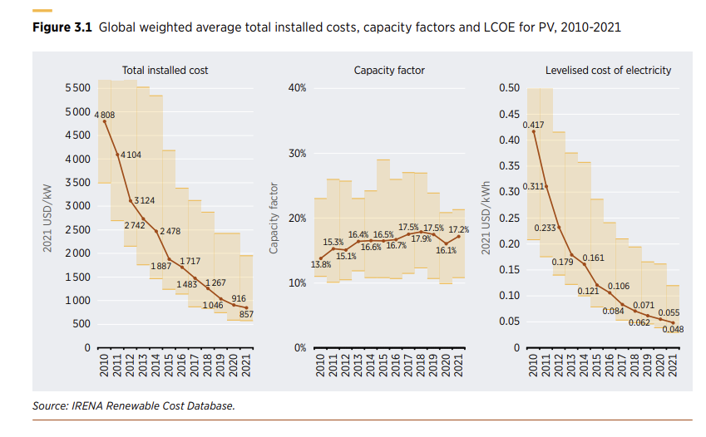

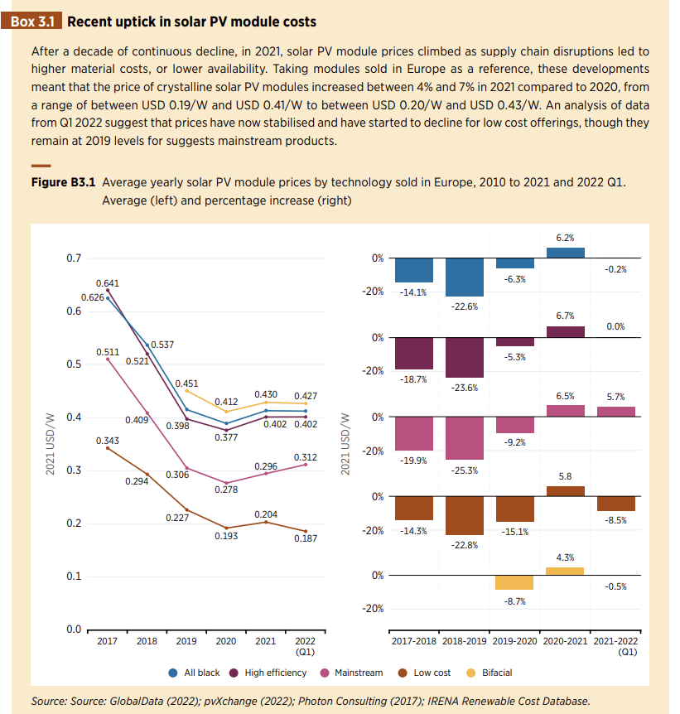
Could develop it to take in information on the web about the prices of materials needed for solar panels and then predict how the prices could change affecting the amount saved by consumers.

